Chapter name in font ( 16 Times new roman ) like here

Subhead title in font ( 14 Times new roman) like this

All rest in font ( 12 Times new roman ) like here

All images is in center however the size of it

Please use the styles here to make it ease for change font number and style

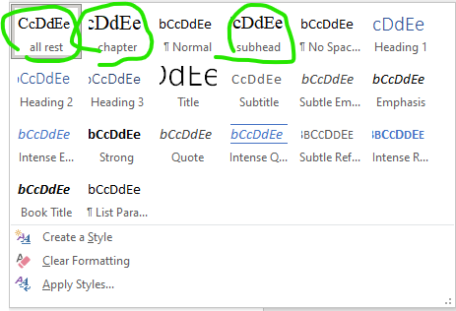

To make the number under the letter in equation like this

$$A_{f}$$

Use



Then

